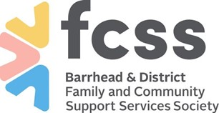
Barrhead & District FCSS Society – CODE OF CONDUCT
Barrhead & District FCSS Society, incorporated under the Society’s Act of Alberta, is an organization that provides preventative services to the Town and County of Barrhead. This Code of Conduct reflects the Mission and Vision Statements of this organization.
This Code of Conduct applies to all volunteers and public working in FCSS sponsored programs.
Democratic Values:
- Always give honest and impartial advice
- Always support individual(s) and provide information on the results of the work
- Work within the laws of Canada
Professional Values:
- Use public funds properly, effectively and efficiently
- Always be committed to serve and continually improve the quality of service
Ethical Values:
- Always strive to ensure that the value of transparency is upheld while respecting the duties of confidentiality under the law
- Act in a manner that can withstand the closest public scrutiny
People Values:
- The value of every person should always inspire us to be respectful and responsible
- People should always be treated with fairness and civility
- The FCSS organization leads through participation, openness and communication and with respect for diversity

Signature:_____________________________
Date:_________________________________

