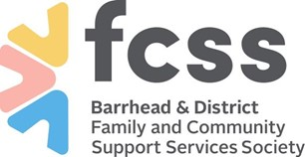
Barrhead & District Family and Community Support Services Society

Date_________________

To: Barrhead RCMP Detachment
4729-61 Avenue
Barrhead, AB T7N1A3
Admin 780-674-4848

Re: Criminal Records and Vulnerable Sector Check Request Letter

To: Whom It May Concern

____________________________________ has applied to volunteer with Barrhead & District Family and Community Support Services Society (FCSS).

Our volunteer policy requires this applicant to submit a:

- Criminal Records & Vulnerable Sector (VS) Check prior to approval and placement of volunteer

We respectfully request your assistance in this regard. If further verification is required, please call our office, 780-674-3341.

Thank You

Karen Gariepy
Executive Director
Barrhead & District FCSS Society

