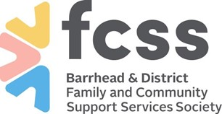
Barrhead & District Family and Community Support Services Society

Date_________________

To: Prospective Volunteers

Re: CWIS Request Letter
Intervention Record Checks are no longer processed out of the local Barrhead Office. For prospective volunteers, please email cs.ircnorthcentral@gov.ab.ca and they will send you the form, along with instructions. Adobe is required to fill out the form, and ID needs to be scanned and submitted with the application.

Our volunteer policy requires that applicants submit a:

- Child Intervention Record Check prior to approval and placement of volunteer

Should you require assistance in completing this request, please call our office, 780-674-3341.

Thank You

Karen Gariepy
Executive Director
Barrhead & District FCSS Society

